

|  |
| --- |
| Business Template  **Subject areas** |
| **Logo / Image** |

Contents

1 Business Description 3

1.1 Business background 3

1.2 Problems. Current Situation 3

1.3 The benefits of implementing a database. Project Vision 3

2 Model description 3

2.1 Definitions & Acronyms 3

2.2 Logical Scheme 3

2.3 Objects 3

# 

# Business Description

## Business background

Employment agencies primarily aim to connect candidates with their desired jobs as well as improve skills for future jobs. The agencies themselves manage a large number of documents and details that are of key importance for each candidate in order to make it as easy as possible for them to apply for a job.

## Problems. Current Situation

The problems are as follows: too many documents, non-updating of constantly changing data, insecurity because not all data is entered into the database, too slow process of employment itself

The current situation is that most agencies rely on spreadsheets, directly connecting candidates with employers and sending sensitive data via email. Some agencies have started to make changes, but most of them lack knowledge and practice in working with the base and its organisation. As this job becomes more and more serious and demanding, agencies are expected to introduce a better-structured and more adequate solution for further

## the Benefits of implementing a database. Project Vision

The goal is to have an easy insight into the very key data about the individual, which includes age, state of health and professional education. The data is stored in a safe place, and by regularly updating it can be accessed very quickly at any time. More adequate connection of the individual with the employer and market needs according to their qualifications

# Model description

## Definitions & Acronyms

* **Candidate**: Represents people applying for positions
* **Job**: Represents available job positions posted by employers
* **Application**: Tracks candidates' applications for jobs and their status
* **Placement**: Records successful job placements
* **Recruiter**: HR managing recruitment processes
* **Interview**: Records interview details between candidates and recruiters
* **Job Category**: Categorizes jobs into various industry sectors
* **Skill**: Represents different skills candidates may have
* **Candidate Skill**: Connects candidates to their respective skills (many-to-many).
* **Service Requests**: Tracks additional services (e.g., resume writing, interview coaching, skills development)
* **Job Health**: Connects jobs to specific health conditions and how they affect work
* **Health Condition**: Defines various medical or mental health conditions relevant to job roles

Acronyms

* **PK** – Primary Key
* **FK** – Foreign Key
* UQ- Unique key
* CHECK- A constraint that ensures a column's values meet a specific condition( here is part where we check experience of candidate and status as well as job type)
* **ENUM** – Enumerated Data Type (Predefined Set of Values)
* **INT** – Integer (Numeric Data Type)
* **VARCHAR** – Variable-Length String
* **TEXT** – Large Text Field
* **DECIMAL** – Numeric Field with Decimal Precisio

## Logical Scheme

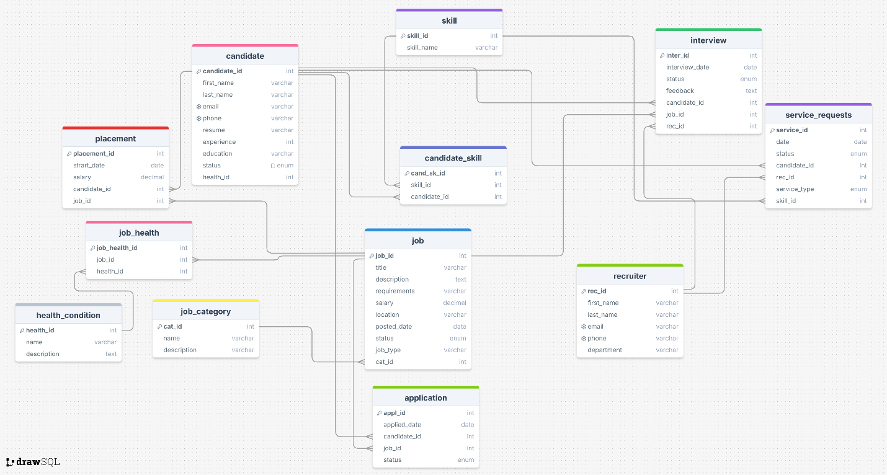

## Objects

Table Description

This is detailed structure of each entity, all types and descriptions are showed in these tables

|  |  |  |  |
| --- | --- | --- | --- |
| Table Name | Field name | Field Description | Data Type |
|  |  |  |  |
| candidate | candidate_id | Id of each candidate, PK | Int |
| first_name | Name of candidate | varchar(255) |
| last_name | Last name of candidate | varchar(255) |
| email | Email of each candidate, UQ | varchar(255) |
| phone | Phone number of each candidate, UQ | varchar(255) |
| resume | CV and motivation letter from candidate | varchar (255) |
| experience | Years of experience for each candidate , CHECK | int |
| education | High school and faculty of candidate | varchar(255) |
| status | Status of candidate at this moment (active, inactive), CHECK | enum |
| health_id | Health condition of candidate | int |

|  |  |  |  |
| --- | --- | --- | --- |
| Table Name | Field name | Field Description | Data Type |
|  |  |  |  |
| job | job_id | Id of each job, PK | Int |
| title | Main title of job | varchar(255) |
| description | Detailed description of job | text |
| requirements | What one candidate is needed for job | varchar(255) |
| salary | Expected salary | Decimal |
| location | Type of : on site or remote | varchar (255) |
| posted_date | When job is posted | date |
| status | Status of job(open, closed) | enum |
| job_type | What kind of job for candidate (contract, full time, internship, freelance, part time), CHECK | varchar (255) |
| cat_id | Category of job | int |

|  |  |  |  |
| --- | --- | --- | --- |
| Table Name | Field name | Field Description | Data Type |
|  |  |  |  |
| application | appl_id | Id of each application, PK | Int |
| appliedDate | Date when candidate applied for job | date |
| candidate_id | Id of each candidate, FK | int |
| Job_id | Id of specific job, FK | int |
| Status | Status of application (pending, interview, declined), CHECK | enum |

|  |  |  |  |
| --- | --- | --- | --- |
| Table Name | Field name | Field Description | Data Type |
|  |  |  |  |
| placement | placement_id | Placement of each id, PK | Int |
| start_date | Date when candidate will start job | date |
| salary | Information about salary for candidate | decimal |
| candidate_id | Id of specific candidate , FK | int |
| job_id | Id of specific job, FK | int |

|  |  |  |  |
| --- | --- | --- | --- |
| Table Name | Field name | Field Description | Data Type |
|  |  |  |  |
| recuiter | rec_id | Id of each recuiter, PK | Int |
| first_ name | Name of recuiter | int |
| last_ name | Surname of recuiter | int |
| email | Email of recuiter, UQ | varchar(255) |
| phone | Phone number of recuiter, UQ | int |
| department | In which is recuiter (hr mostly) | varchar(255) |

|  |  |  |  |
| --- | --- | --- | --- |
| Table Name | Field name | Field Description | Data Type |
|  |  |  |  |
| interview | inter_id | Id of each interview, PK | Int |
| interview_date | Date of interview | date |
| status | Status of interview(completed, waiting), CHECK | text |
| feedback | Text file with details and results of interview | text |
| candidate_id | Id of candidate, FK | int |
| job_id | Id of specific job, FK | int |
| rec_id | Id of recuiter who will do interview, FK | Int |

|  |  |  |  |
| --- | --- | --- | --- |
| Table Name | Field name | Field Description | Data Type |
|  |  |  |  |
| job_category | cat_id | Id of category, PK | Int |
| name | Name of category for job | varchar(255) |
| description | Description of each category | varchar(255) |

|  |  |  |  |
| --- | --- | --- | --- |
| Table Name | Field name | Field Description | Data Type |
|  |  |  |  |
| skill | skill_id | Id of each skill, PK | Int |
| skill_name | Name of skill | varchar(255) |

|  |  |  |  |
| --- | --- | --- | --- |
| Table Name | Field name | Field Description | Data Type |
|  |  |  |  |
| candidate_skill | cand_sk_id | Id of each candidate-skill, PK | Int |
| skill_id | Id of skill, FK | int |
| candidate_id | Id of candidate, FK | int |

|  |  |  |  |
| --- | --- | --- | --- |
| Table Name | Field name | Field Description | Data Type |
|  |  |  |  |
| health_condition | health_id | Id of each health condition, PK | Int |
| name | Name of condition | varchar(255) |
| description | Detail description of condition and all important factors | text |

|  |  |  |  |
| --- | --- | --- | --- |
| Table Name | Field name | Field Description | Data Type |
|  |  |  |  |
| job_health | job_health_id | Id of condition associated with job, PK | Int |
| job_id | Id of job, FK | int |
| health_id | Id of condition | int |

|  |  |  |  |
| --- | --- | --- | --- |
| Table Name | Field name | Field Description | Data Type |
|  |  |  |  |
| service_request | service_id | Id of each service, PK | Int |
| date | date when candidate will have specific service | date |
| status | Status service (pending, complete) | enum |
| candidate_id | Id of candidate who will attend service, FK | int |
| rec_id | Id of recuiter who will be part of service, FK | int |
| service_type | Type of service ( resume writing, interview coaching, skills development ) | enum |
| skill_id | Id of each skill (for skills development) | int |
|

Comments on table relationships

1. candidate 1-m candidate_skill m-1 skill (Many-to-Many, that’s why we have third table)
   * A candidate can have multiple skills, and each skill can be associated with multiple candidates
2. candidate 1-m application m-1 job (One-to-Many & Many-to-One)
   * A candidate can apply for multiple job.
   * A job can have multiple candidates applying for it
   * Application keeps track of all job application
3. candidate 1-m interview
   * A candidate can have multiple interviews for different jobs.
4. candidate 1-m placement m-1 job
   * Once a candidate is selected, they are placed in a job.
   * A placement record is created to track job start date and salary.
5. job_category 1-m job (One-to-Many)
   * A job can have multiple categories
6. job 1-m job_health m-1 health_condition (Many-to-Many)

* One job can be associated with more conditions( that candidate have )
* And one condition can be associated with more jobs, that’s why we have third table (jobhealth)

1. job 1-m application(one to many)

* One job can have multiple application

1. job 1-m interview

* One job can have multiple interviews

1. recuiter 1–m interview (one to many)

* One recuiter can be on multiple interviews

1. recuiter 1-m service_request (one to many)

* One recuiter can be on multiple services (ex: both resume writing, interview coaching)

1. skill 1-m service_request

* One skill can be in multiple skills development

Example with data

customer table:

|  |  |  |  |  |  |  |  |  |  |
| --- | --- | --- | --- | --- | --- | --- | --- | --- | --- |
| **candidate_id** | **first_name** | **last_name** | **email** | **phone** | **resume** | **experience** | **education** | **status** | **health_id** |
|  |  |  |  |  |  |  |  |  |  |
| 1 | John | Doe | john.doe@email.com | 123456789 | resume.pdf | 5 years | BSc CS | Active | 2 |
| 2 | Jane | Smita | jane.smith@email.com | 987654321 | mycv.pdf | 2 years | MSc IT | Active | 1 |

job table:

|  |  |  |  |  |  |  |  |  |  |
| --- | --- | --- | --- | --- | --- | --- | --- | --- | --- |
| **job_id** | **title** | **description** | **requirements** | **salary** | **location** | **posted_date** | **status** | **job_type** | **cat_id** |
| 101 | Software Engineer | Backend Developer | Python, SQL, PHP | 5000.00 | Remote | 2025-03-10 | Open | Full-time | 1 |
| 102 | Data Analyst | Data visualization role | Excel, PowerBI | 4000.00 | On-site | 2025-03-11 | Open | Contract | 2 |

application table:

|  |  |  |  |  |
| --- | --- | --- | --- | --- |
| **appl_id** | **applied_date** | **candidate_id** | **job_id** | **status** |
| 1 | 2025-03-12 | 1 | 101 | Pending |
| 2 | 2022-03-13 | 2 | 102 | interview |

placement table:

|  |  |  |  |  |
| --- | --- | --- | --- | --- |
| **placement_id** | **start_date** | **salary** | **candidate_id** | **job_id** |
| 1 | 2025-05-10 | 1500.00 | 1 | 101 |

recruiter table:

|  |  |  |  |  |  |
| --- | --- | --- | --- | --- | --- |
| **rec_id** | **first_name** | **last_name** | **email** | **phone** | **department** |
| 301 | mark | johnson | Mark.hr@email.com | 555123 | HR |

interview table:

|  |  |  |  |  |  |  |
| --- | --- | --- | --- | --- | --- | --- |
| **inter_id** | **interview_date** | **status** | **feedback** | **candidate_id** | **job_id** | **rec_id** |
| 501 | 2025-03-14 | Completed | Strong skills | 1 | 101 | 301 |

job_category table:

|  |  |  |  |  |  |  |  |
| --- | --- | --- | --- | --- | --- | --- | --- |
| | **cat_id** | | --- | | |  | **name** |  | | --- | --- | --- | | | **description** | | --- | |
| |  | | --- | | 1 | | IT & Software | |  | | --- | | Tech jobs | |

skill table:

|  |  |  |  |
| --- | --- | --- | --- |
| **skill_id** | |  | | --- | |  |  |  | | --- | | **skill_name** | |
| 1 | python |
| 2 | SQL |

candidate_skill table:

|  |  |  |
| --- | --- | --- |
| **cand_sk_id** | **skill_id** | **candidate_id** |
| **1** | **1** | **1** |
| **2** | **2** | **1** |

**service_request table:**

|  |  |  |  |  |  |  |
| --- | --- | --- | --- | --- | --- | --- |
| **service_id** | **date** | **status** | **candidate_id** | **rec_id** | **service_type** | **skill_id** |
| **1** | **2025-03-10** | **Pending** | **1** | **301** | **Resume writing** | **null** |
| **2** | **2025-03-11** | **completed** | **2** | **301** | **Interview coaching** | **null** |

**job_health table:**

|  |  |  |
| --- | --- | --- |
| **job_health_id** | **job_id** | **health_id** |
| **1** | **101** | **1** |
| **2** | **102** | **2** |

**health_condition table:**

|  |  |  |
| --- | --- | --- |
| **health_id** | **name** | **description** |
| **1** | **Without condition** | **No special treatment needed** |
| **2** | **Anxiety disorder** | **Flexible work environment needed** |